**USER MANUAL**

**FRAMEWORK AGREEMENT (Acceptance of FA by the Supplier)**

**Electronic Government Procurement System – eGP System**

***Provider:*** *Joint Venture of Tenece Professionals and Nextenders (India) Pvt. Ltd.*

*The information contained in this document is private and confidential and intended only for the use of eGP System of PRAZ. The contents of this documents should not be used before prior authorization of PRAZ.*

Table of Contents

Getting Started 4

Part I. System Log-In and Credentials 4

Part II. Forgot Password and Change Password 4

Part III. Supplier Accepting the Framework Agreement 4

Part III. Supplier Accepting Mini Competition 7

Part III. Supplier Purchase Order Approval 9

**Acronyms: -**

|  |  |
| --- | --- |
| EC | Evaluation Committee |
| FA | Framework Agreement |
| QBS | Quality Based Selection |
| PMU | Procurement Management Unity |
| BEC | Bid Evaluation Committee |

**Note:** The procurement process to enter into Framework Agreement would be on bid notice created from PR and processed till award. Framework Agreement for goods would be as per list of items on an agreed specification with indicative quantities for the duration of the FA.

Framework Agreement for necessary and desirable goods that are repeatedly required by the procuring entity, but by their nature, use, or characteristic, the quantity and/or exact time of need cannot be correctly pre-determined; and, in case of goods, procuring entity may not carry the stock or oblige to purchase goods within given period.

Framework Agreement, as a contractual arrangement between procuring entity and suppliers, may be used for goods that are repeatedly required by the procuring entity (PE) in the regular day to day business activities and services. Infrastructure projects are not considered while establishing the Framework Agreement (FA). Establishment of Framework Agreement (FA) happen between procuring entity and multiple suppliers and can be viewed online later for record purpose.

**Getting Started**

This section will illustrate the step-by- step walkthrough of the system from initiation trough exit. The logical arrangement of the information shall enable the Procuring Entity to fully understand the flow and functionality of the system.

**Part I. System Log-In and Credentials**

Please refer **User Manual - Manage Profile for Procuring Entity**.

**Part II. Forgot Password and Change Password**

Please refer **User Manual - Manage Profile for Procuring Entity.**

**Part III. Supplier Accepting the Framework Agreement**

**Step 1: Supplier** Log in to the system by selecting user type as supplier, username and password. The system directs the user to the dashboard with the pending task.

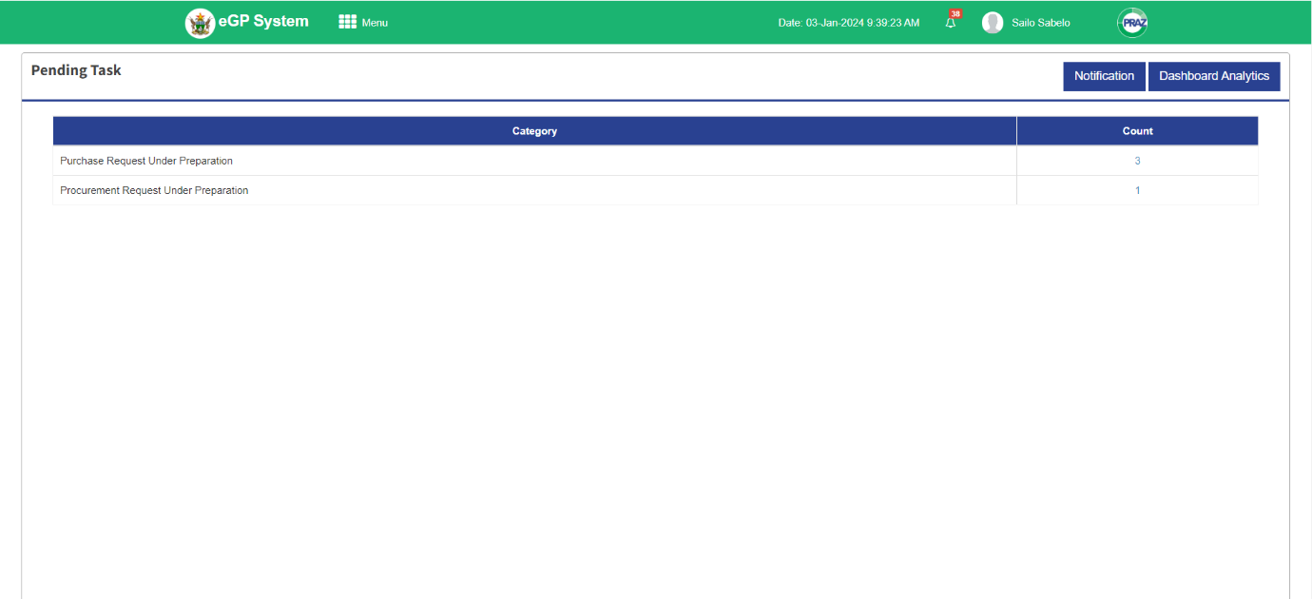

**Step 2:** Click **Menu** at the top left corner of the dashboard, the system responds with the Submenus for the Supplier.

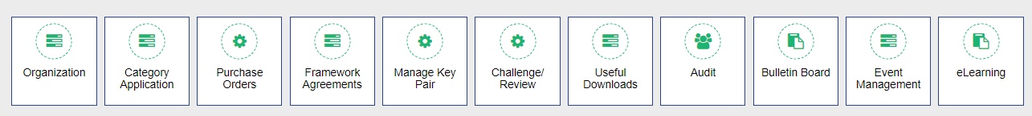

**Step 3:** Click **Framework Agreements,** the system responds with the submenus under Framework Agreements.

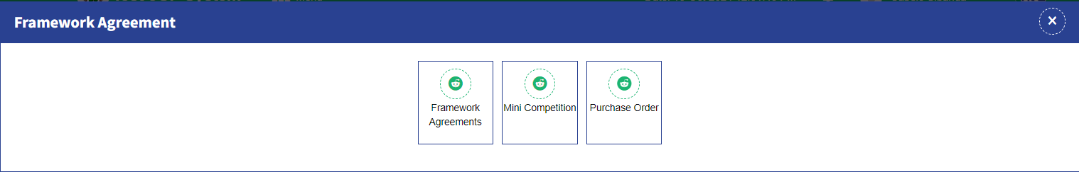

**Step 4:** Click **Framework Agreements** and the system responds with the FAs to be accepted by the Supplier.

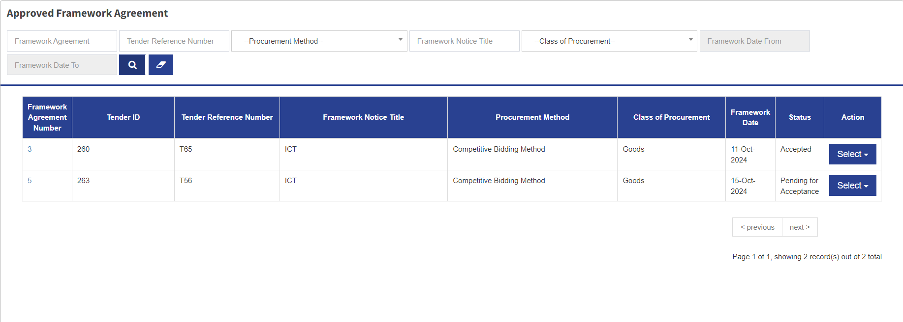

**Step 5:** From the list, select the FA to accepted that is pending for Acceptance. Click the **Select** dropdown and the system responds with two options, View Framework Agreements and View Comments. Click View Framework Agreement and the system respond with the FA to be accepted.

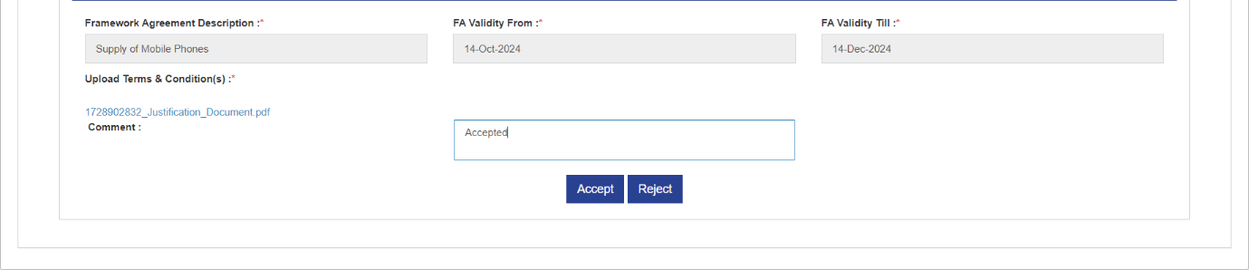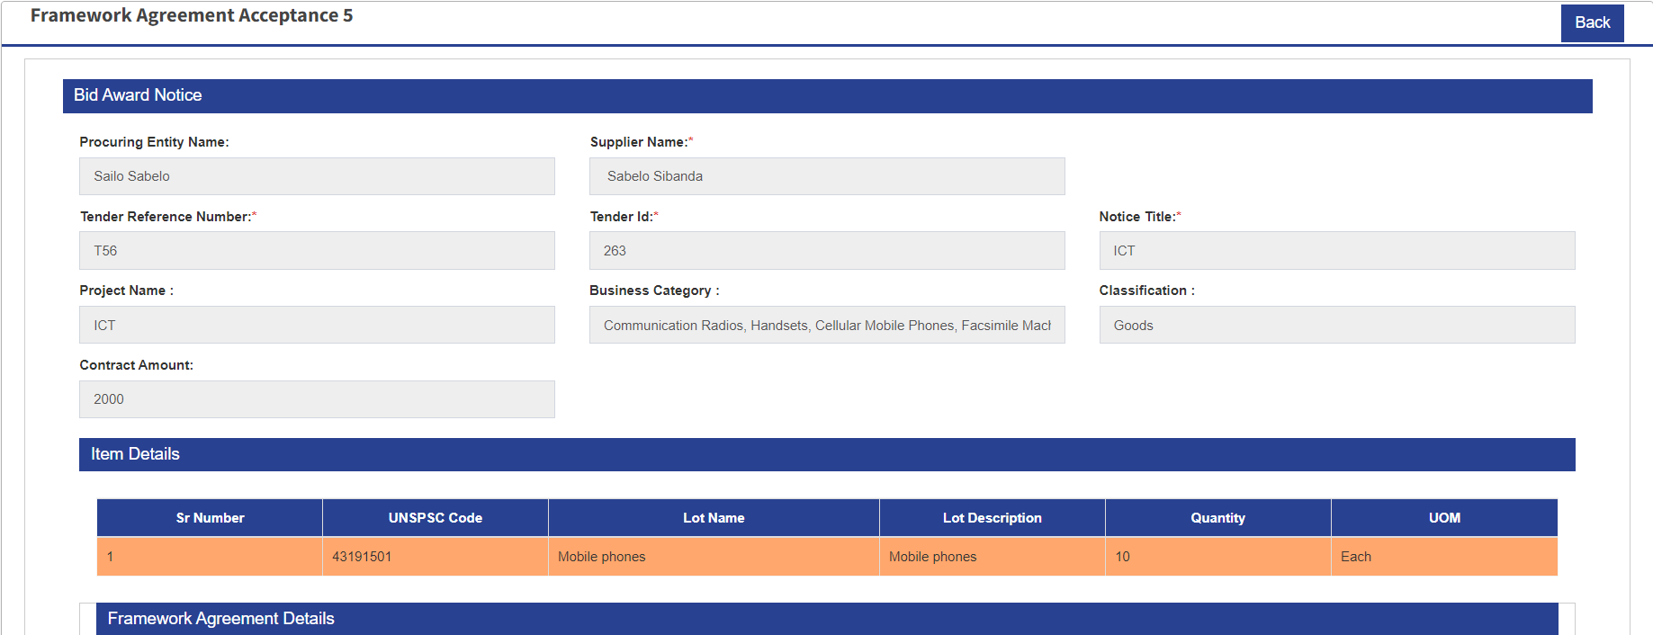

**Step 6:** Go through the Framework Agreement details including terms and condition. To Accept click Accept button and the system responds with the confirmation message “Do you want to Accept & Establish the Framework Agreement with the Procuring Entity?”

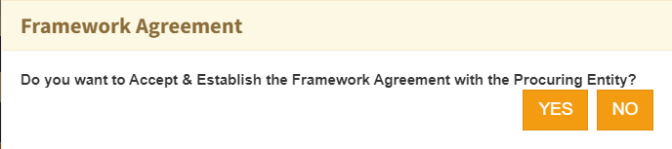

**Step 7:** If yes click YES and the system responds with a message confirming that the Supplier successfully accepted the FA.

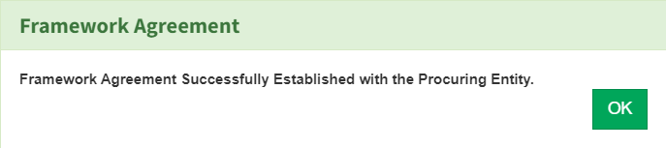

**Step 8:** Click OK.

**Part III. Supplier Accepting Mini Competition**

**Step 1: Supplier** Log in to the system by selecting user type as supplier, username and password. The system directs the user to the dashboard with the pending task.



**Step 2:** Click **Menu** at the top left corner of the dashboard, the system responds with the Submenus for the Supplier.



**Step 3:** Click **Framework Agreements,** the system responds with the submenus under Framework Agreements.



**Step 4** Click **Mini Competition.** The System responds with tenders ready for Mini Competition to be accepted.

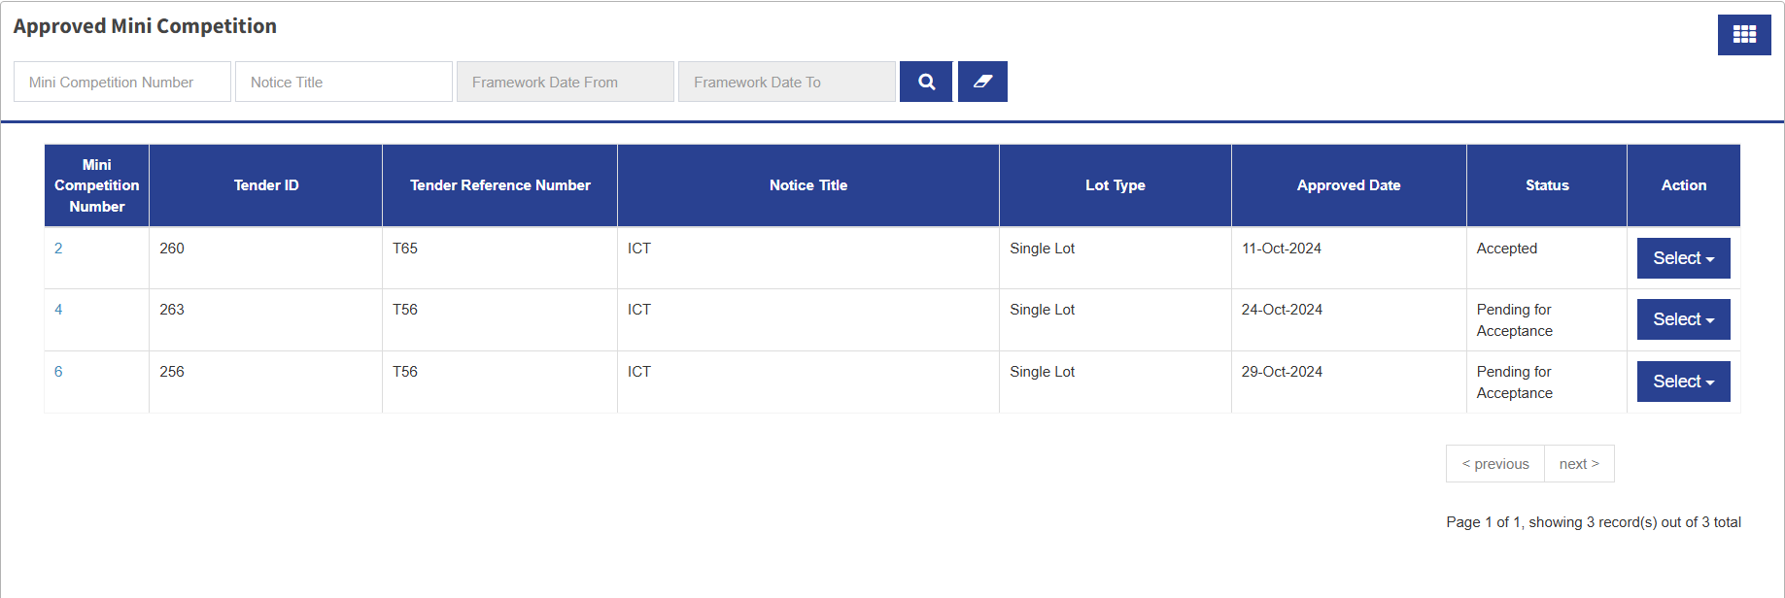

**Step 5:** From select the Tender to Accept Mini Competition. Click **Select** dropdown, the system responds with two options Prepare Response Mini Competition and View Comments. Click Prepare Response Mini Competition. The system responds with the Mini Competition to be accepted.

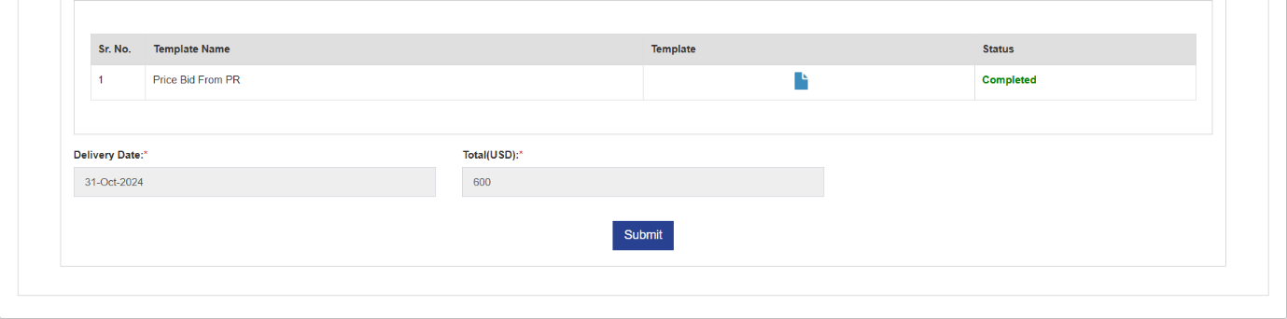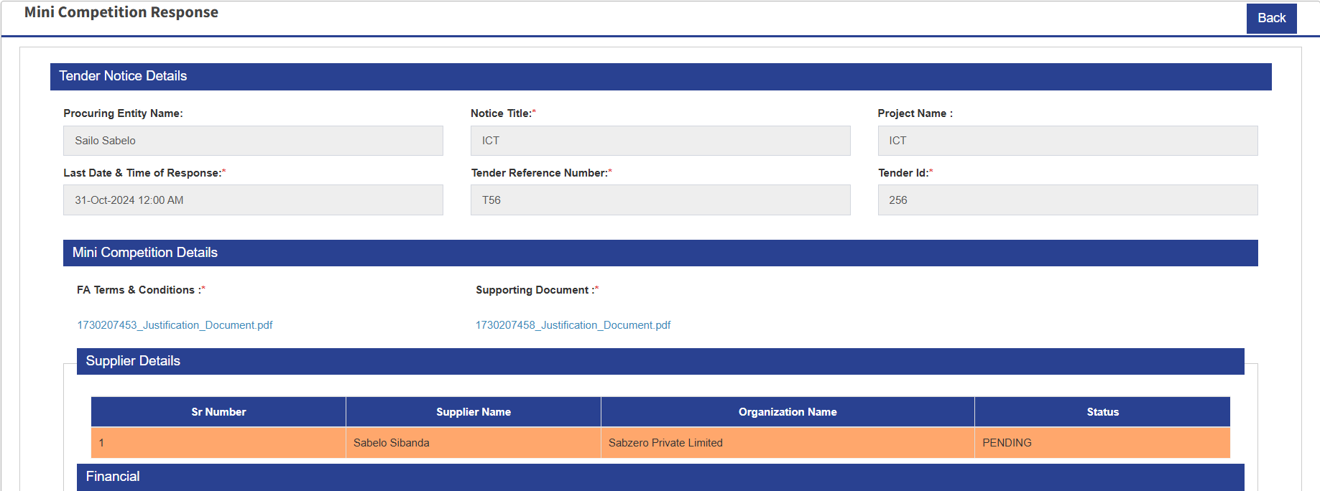

**Step 6:** Go through the Mini Competition and fill on the Price Bid from PR and the delivery date. Click **Submit** and the system responds with a confirmation message “Mini Competition Response saved successfully.”

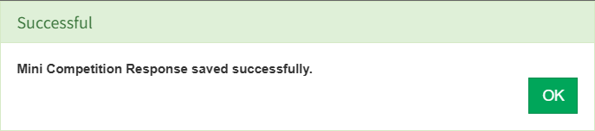

**Step 7:** Click OK.

**Part III. Supplier Purchase Order Approval**

**Step 1: Supplier** Log in to the system by selecting user type as supplier, username and password. The system directs the user to the dashboard with the pending task.



**Step 2:** Click **Menu** at the top left corner of the dashboard, the system responds with the Submenus for the Supplier.



**Step 3:** Click **Framework Agreements,** the system responds with the submenus under Framework Agreements.



**Step 4** Click **Purchase Order.** The System responds with the purchase orders ready for acceptance by the supplier.

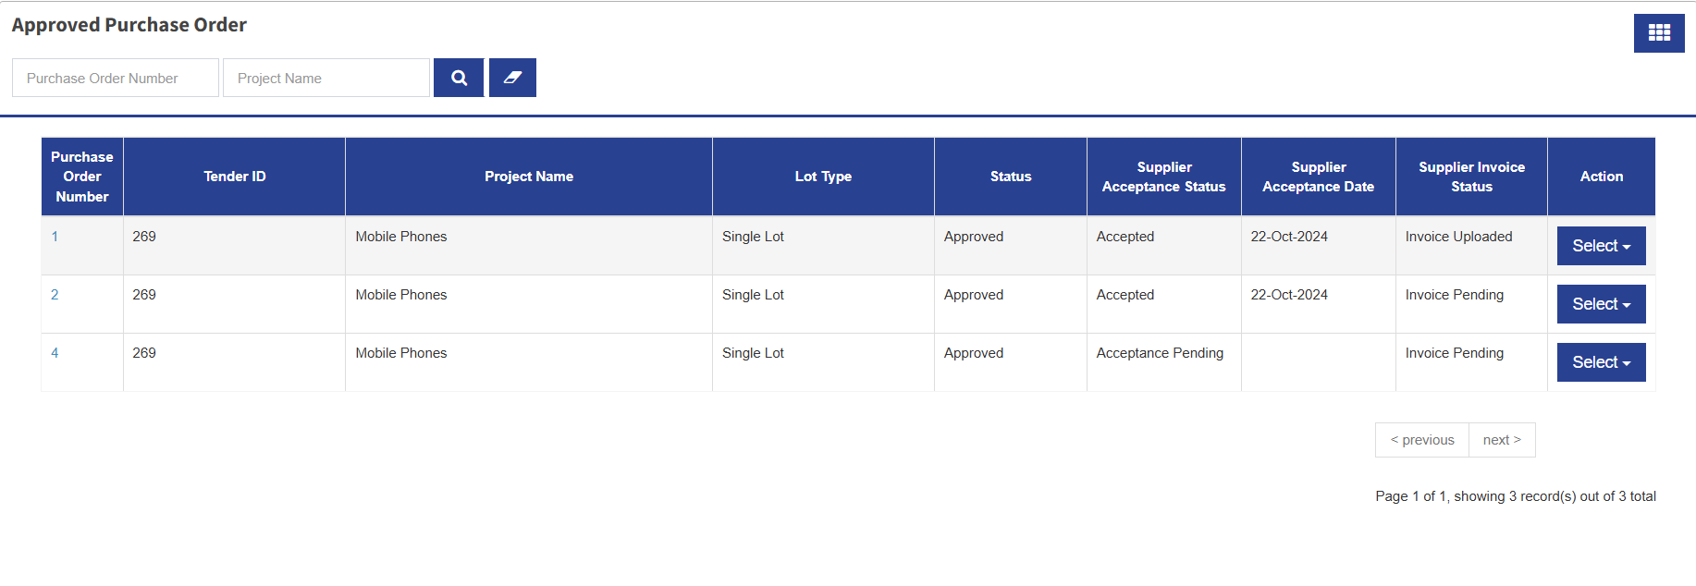

**Step 5:** To accept the Purchase Order, go to the list and pick the one to accept. Click Select dropdown and the system responds with the option View & Acceptance Purchase Order. Click View & Acceptance Purchase Order and the system responds with the page to accept purchase order.

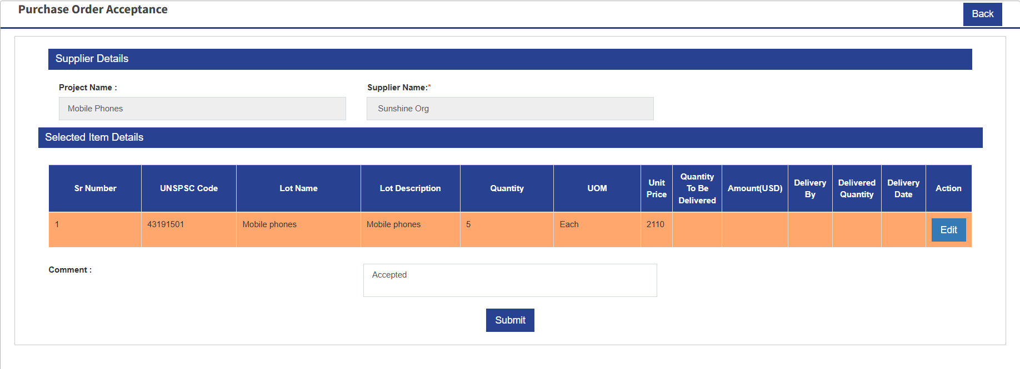

**Step 6:** To proceed, the supplier can update the line Item by clicking Edit and the Comment and submit to accept. Click **Submit** button and the system responds with the confirmation message confirming that the purchase order accepted successfully.

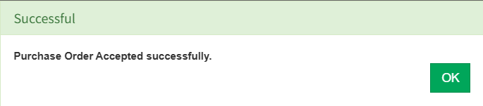

**Step 7:** Click OK. The system responds with the page of Approved Purchase Orders and waiting for the Supplier to upload Invoice.

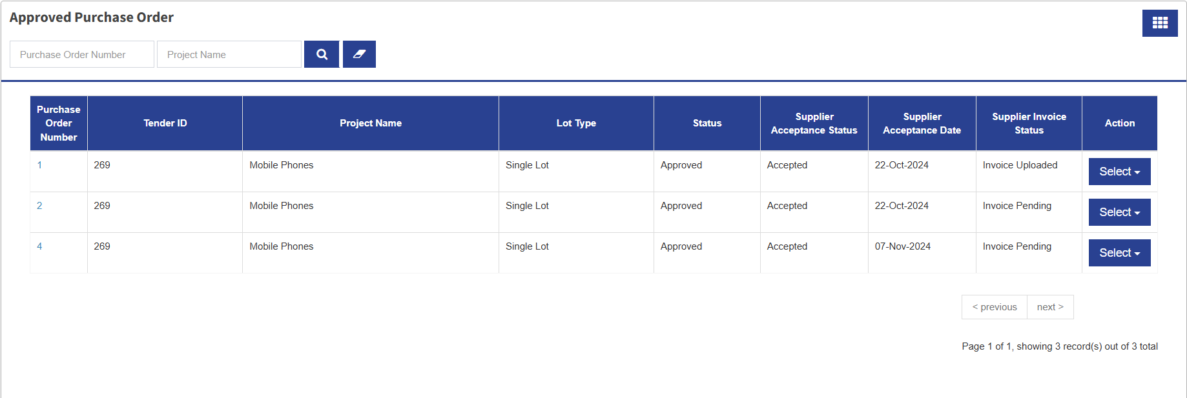

**Step 8:** After the supplier accepted the purchase order, the next step is to upload the Invoice. To Upload the Invoice, go to Purchase Orders list and then choose the Purchase Order to upload invoice. Click **Select** and the system responds with the option Invoice Order. Click Invoice Order and the system responds with the Invoice Order page.

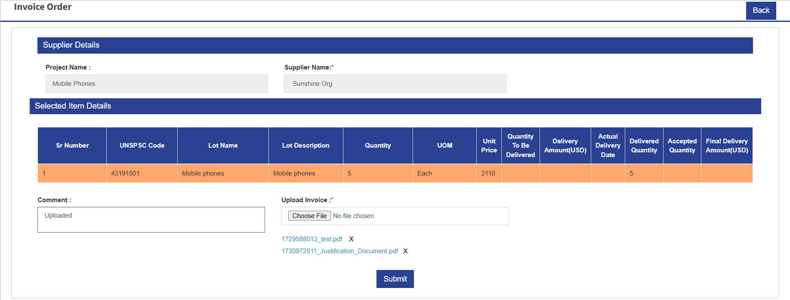

**Step 9:** Comment and then Upload Invoice. Click **Submit** and the system responds with the confirmation message “Purchase Order Invoice Uploaded.”

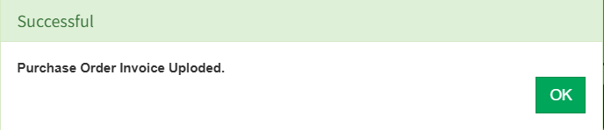

**Step 10:** Click OK. The system redirects to the Approved Purchase Orders page showing that the Invoice was uploaded.

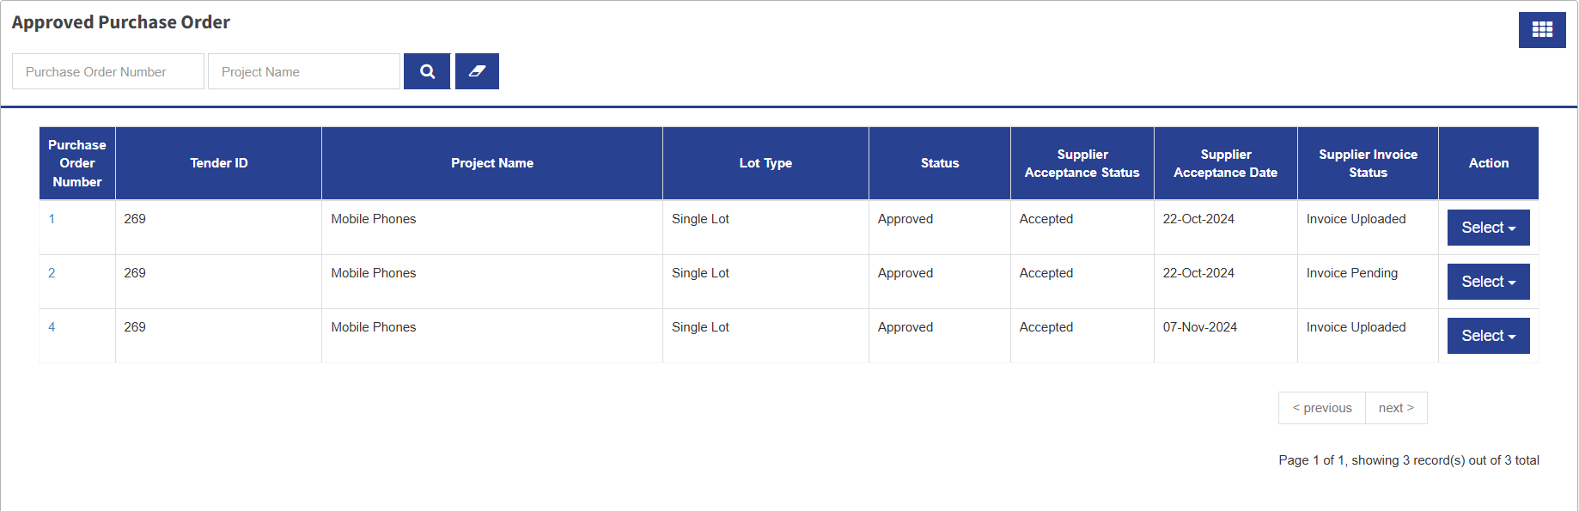

…………………………………………………………………… The End …………………………………………………………………….